Architecture

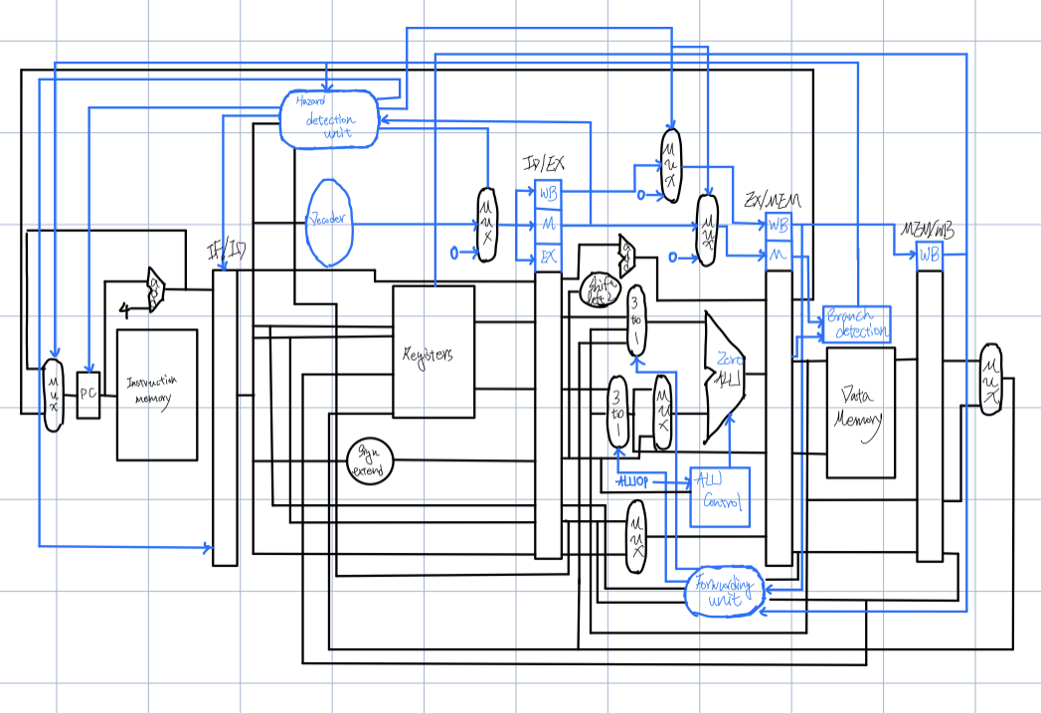

Hardware Module Analysis

ALU: I change the output a little bit. The difference is the zero signal. I use the zero signal to define the relationship for the two inputs. 00 for equal 01 for bigger 10 for less. Besides, there is one more thing. I use the control signal 1000 for multiplication.

Decode: I change the output branch to 3 bits for different types of branch instruction.

PC: I add pcwrite to control whether to renew the pc.

Piplined Reg flush: I add the two signals one for write and another for flush.

MUX3to1: select one signal from three inputs.

Hazard detection unit: It detects the hazard between instruction.

Forward unit: It detects the situation that need to forward the data between instruction.

Branch detection unit: it uses zero and branch to determine whether the branch instruction is conducted.

Other hardware module is same as the previous lab

Problems I Met and Solutions

In this lab, I calculate the alu control signal in different way. I use case statement to implement the function of unit. In the beginning, I do not find that the case statement do not support don’t care detection. It take me some time to figure this problem. Finally I decide to use two level case statement. In the First level, I check the aluOp, and in the second level, it check the fucnt_i[5:0]

Result

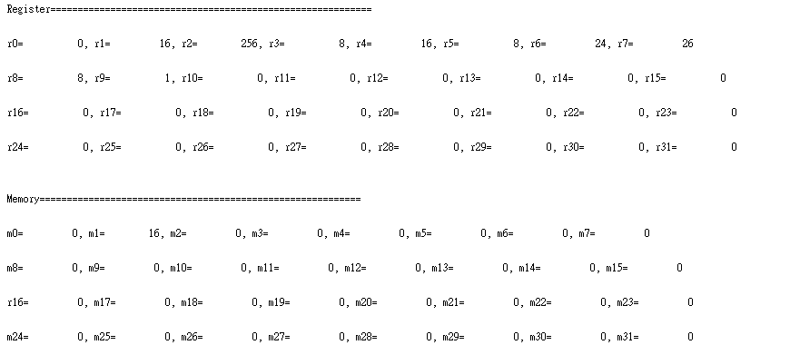

Summary

In this lab, I finally find the bug that exist in the first lab. This bug let me use the different strategy to design the hardware. After the bug is solved, it saves me much of time. The concept is similar to the previous lab. Just add forward unit and hazard detection unit. The concept is same as the teacher taught during the class.